Project Instructions
Scavenger Hunt: Share 5 distinct photos of a place you're exploring.
ASSIGNMENT
This project is a scavenger hunt! Use the camera lens to discover a place with fresh eyes. These creative prompts are intended to help you find a deeper connection with that place — whether it's your city, hometown, or an exotic vacation.
- Bird’s Eye View: Find an elevated perspective. Try rooftips, hills, or even ladders.
- Off the Beaten Path: Aim for any quiet moment, especially those outside tourist or usual haunts. If you're walking on a busy street, turn a corner.
- Middle of the Road: Show forward movement and leading lines. These can be found anywhere, not just the road!
- Signs of Life: Look for details. Think about a "day in the life." How do people eat, talk, work, and fall in love?
- Iconic Postcard: Capture a unique angle of a highly photographed spot.
As you are searching for your photos, it helps to snap as many images as you are moved by, and then edit down later. Have fun with it! Get creative with your styles, and don’t be afraid to push the envelope.
DELIVERABLE
Share 5 distinct photos of the place you’re exploring. A finished project includes:
- One photo representing each of the 5 photo styles
- A brief description of your location
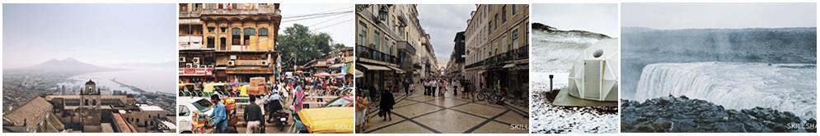
RESOURCES
- I love to use Moment Lenses to get wide-angle and telephoto shots on my iPhone
- My Polaroid Camera is a classic favorite (with new film from The Impossible Project)
- Check out my interview on The Great Discontent
- Check out my first class on Skillshare Mobile Post Production: Editing Your Photos for a deep-dive into my editing process

