**Project Instructions**

Post your favorite photo and share the lens you used!

Post a photo you've taken that you're proud of — whether you took it today or years ago, we'd love to see it! Share the lens and camera you used if you know it, and any notes you have on the photo. Where did you take it, what was the occasion, and why you like it.

**Resources**

* Find further guidance on buying lenses [**here**](https://newatlas.com/camera-lens-buying-guide/29141/)
* Learn more about focal length [**here**](https://www.nikonusa.com/en/learn-and-explore/a/tips-and-techniques/understanding-focal-length.html)

**New to DSLR cameras?** Take Justin's [**Fundamentals of DSLR Photography**](https://skl.sh/dslr_fundamentals_sk)class!

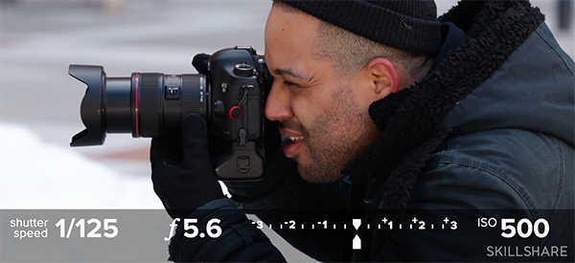

Get out of auto-mode and into manual with these easy-to-follow lessons! You'll learn how to achieve perfect exposure, freeze motion, and control blur. Justin also shares go-to camera settings and must-have gear. [**Click here to join the class**](https://skl.sh/dslr_fundamentals_sk).

**More Skillshare Classes with Justin Bridges**

* Portrait Photography Essentials: One-Light Setups [**here**](https://www.skillshare.com/classes/Portrait-Photography-Essentials-One-Light-Setups/2031854616)
* Fundamentals of Portrait Photography: Using Natural Light to Create Drama [**here**](https://www.skillshare.com/classes/Fundamentals-of-Portrait-Photography-Using-Natural-Light-to-Create-Drama/1375764753)

**More Photography Classes on Skillshare**

* [**Documentary Photographyy**](https://www.skillshare.com/classes/Documentary-Photography-Capturing-Places-and-People/1530569374?via=user-profile) — Ami Vitale
* [**Cityscape Photography**](https://www.skillshare.com/classes/Cityscape-Photography-Capture-Your-City%27s-Story/62903648) — trashhand
* [**Portrait Photography on the Street**](https://www.skillshare.com/classes/Portrait-Photography-on-the-Street-Connecting-with-Strangers/694410255) — Zun Lee