**Project Instructions**

In this class you will be learning how to create a realistic modern house using Blender! The end result will look something like this.

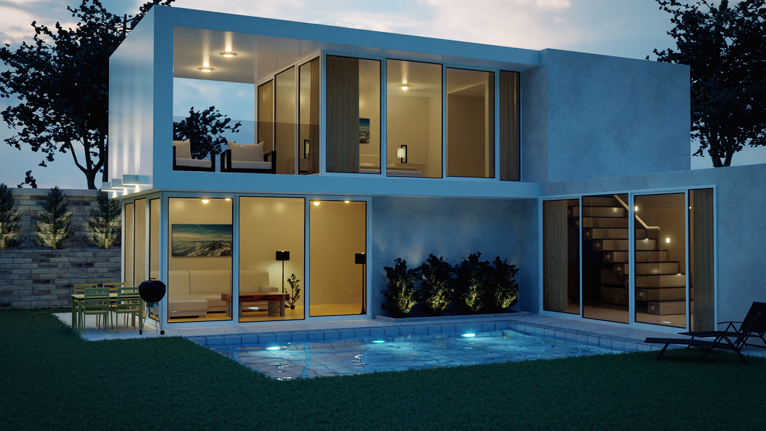

Make sure to download the project files for all the textures, models and reference images for this course!

There is also a tutorial on rendering the final scene using the real-time render engine Eevee!

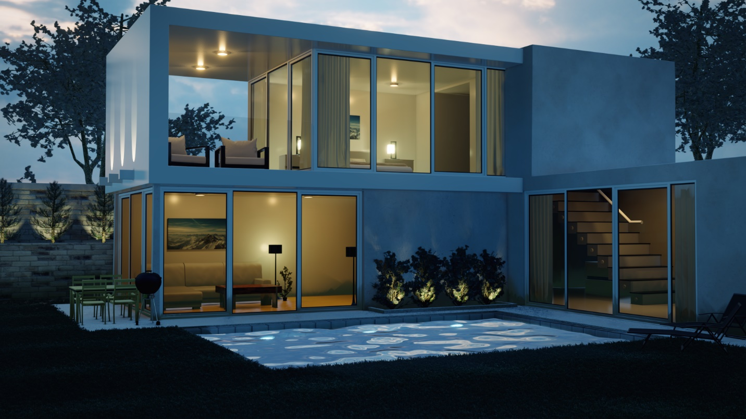

There is also 3 bonus sections of this class. The first one we will learn how to create an organic looking tree!

Make sure you download the 2 textures that will we be using!

[**Leaf Texture**](https://www.textures.com/download/leaves0126/29254)                     [**Bark Texture**](https://www.textures.com/download/barkdecidious0109/17713)

Here is the Result!

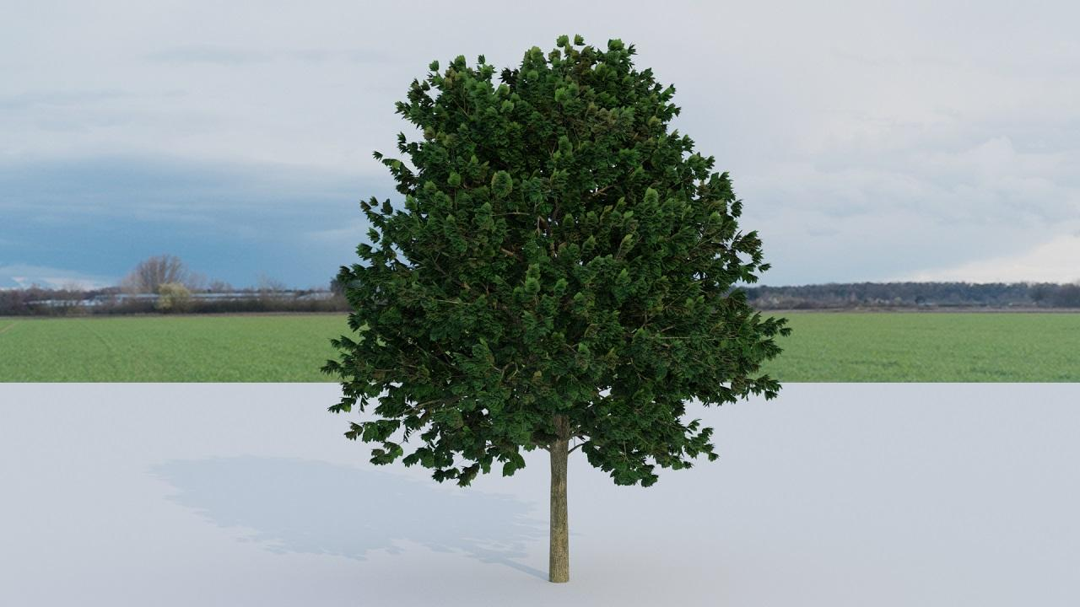

After the tree project we will be learning how to create the modern couch that we put inside the house!

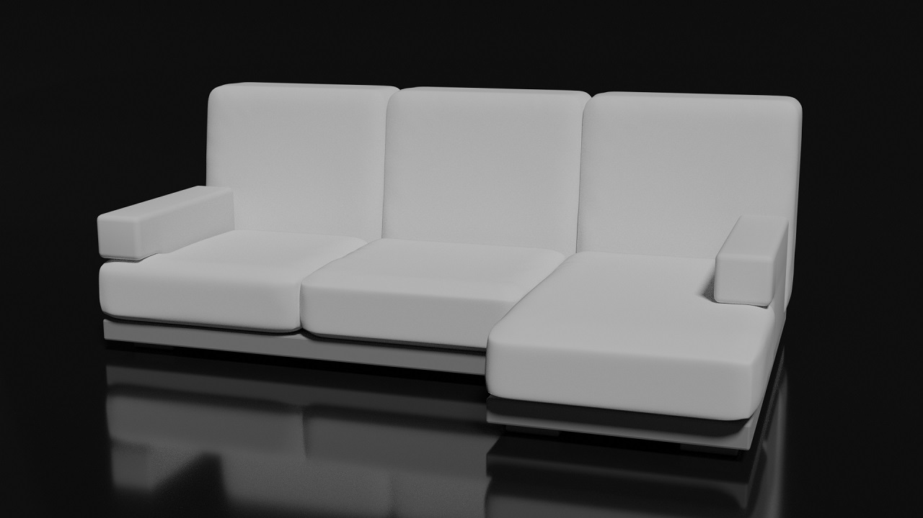

There is also a tutorial on creating a modern bed in Blender! We will cover the cloth simulation and how to easily make pillows using it!

